Lab 7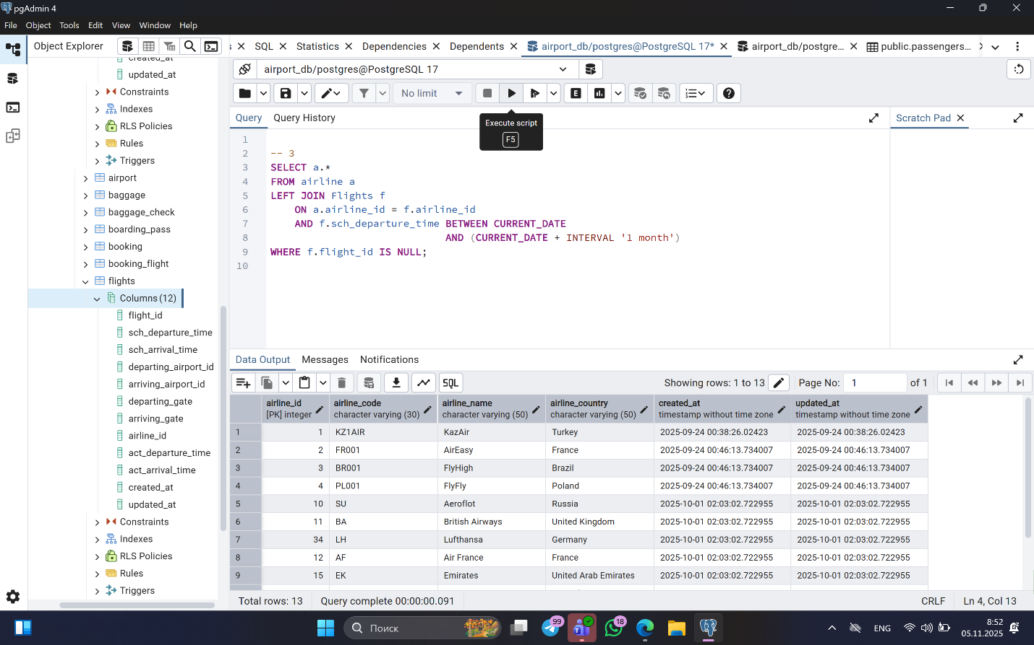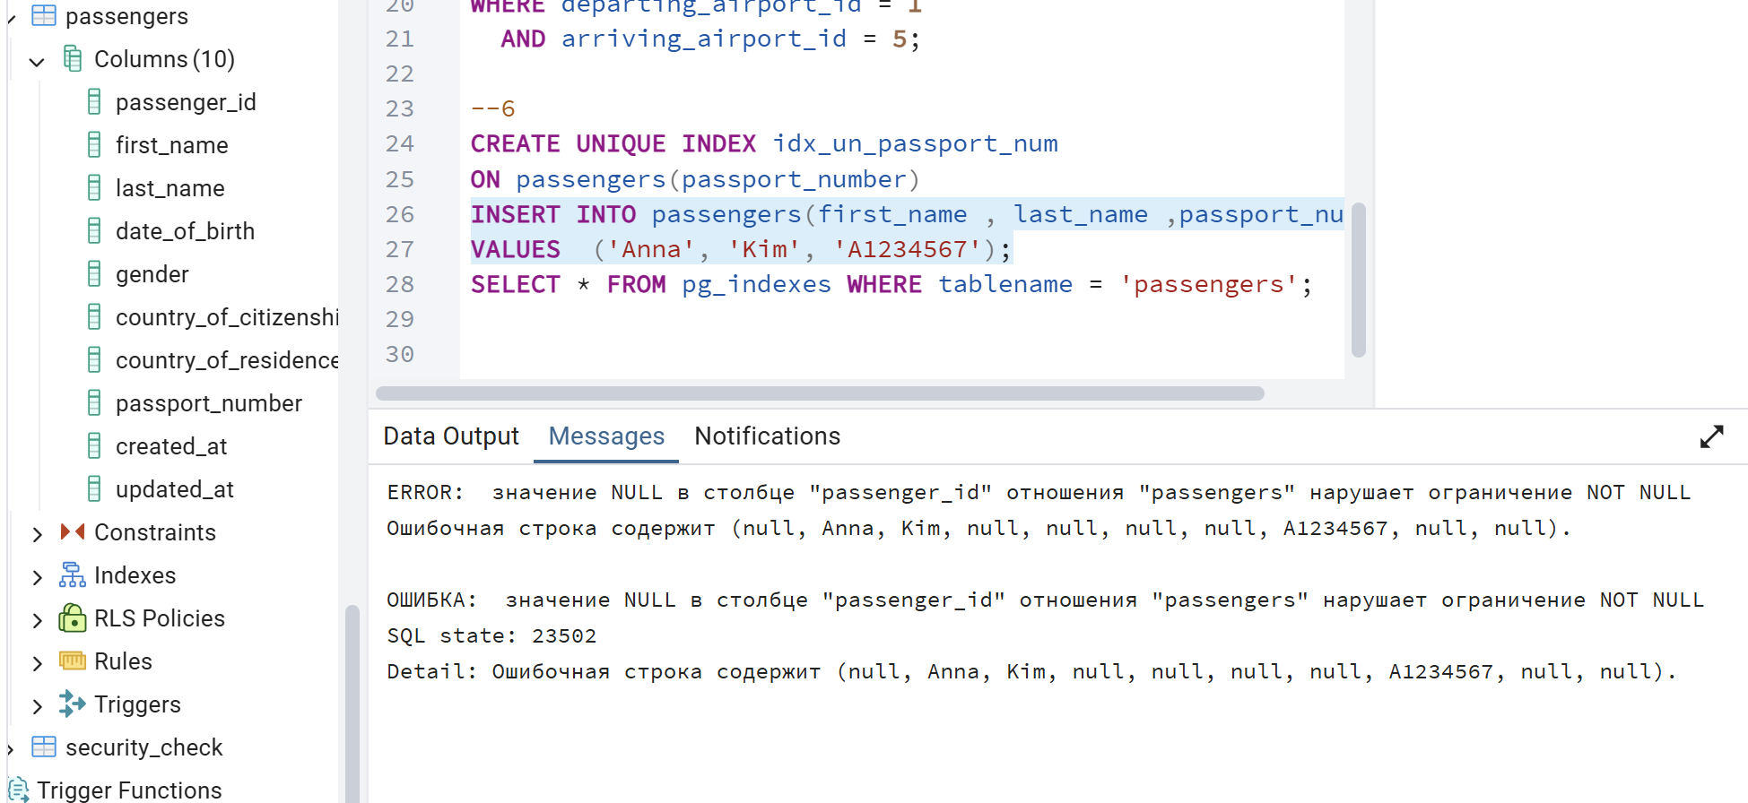The unique index on passport_number ensures that every passenger has a different passport number.
When we insert the first passenger, it works correctly.
However, when we try to insert a second passenger with the same passport number, PostgreSQL throws an error and it prevents duplicates to keep data consistent.
This shows that the unique index is working as a data integrity constraint.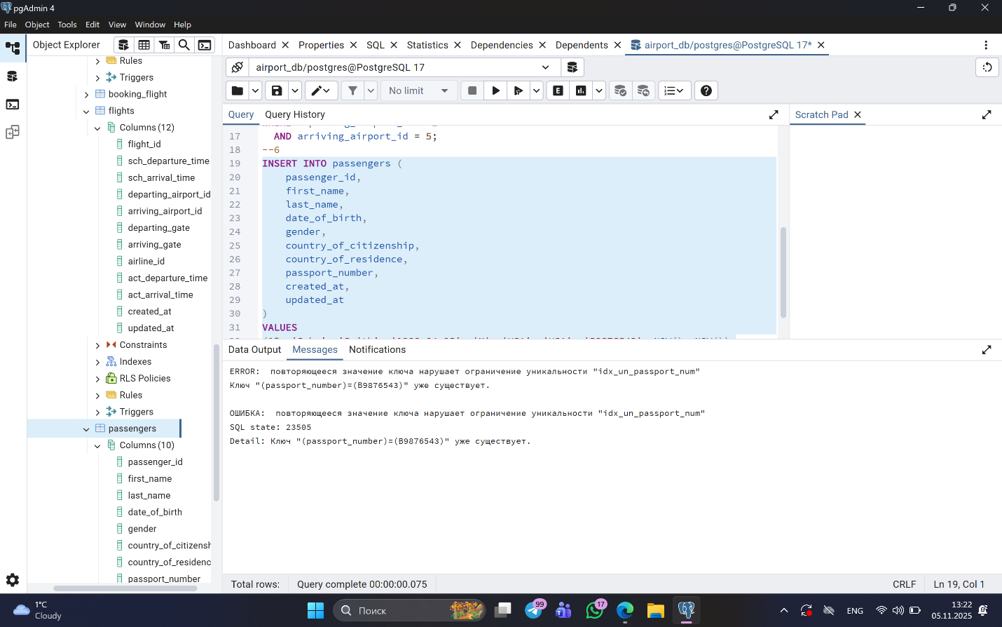
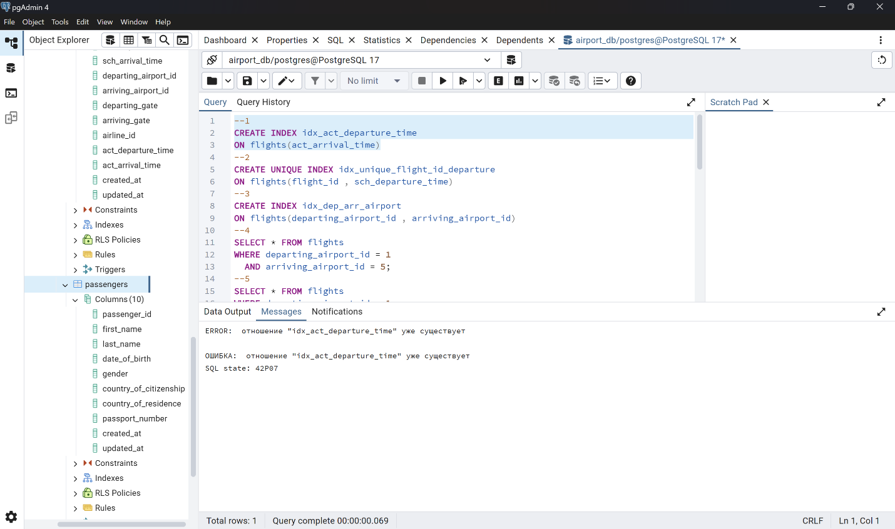
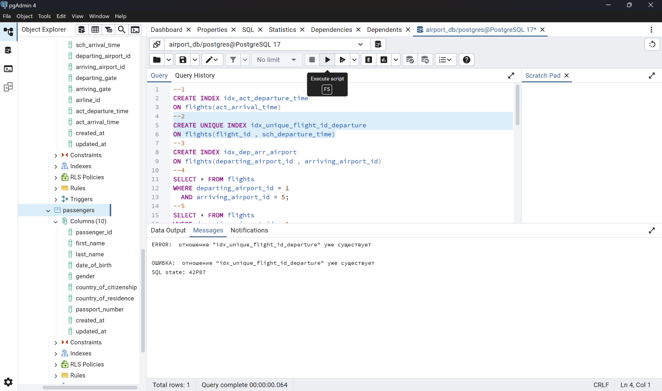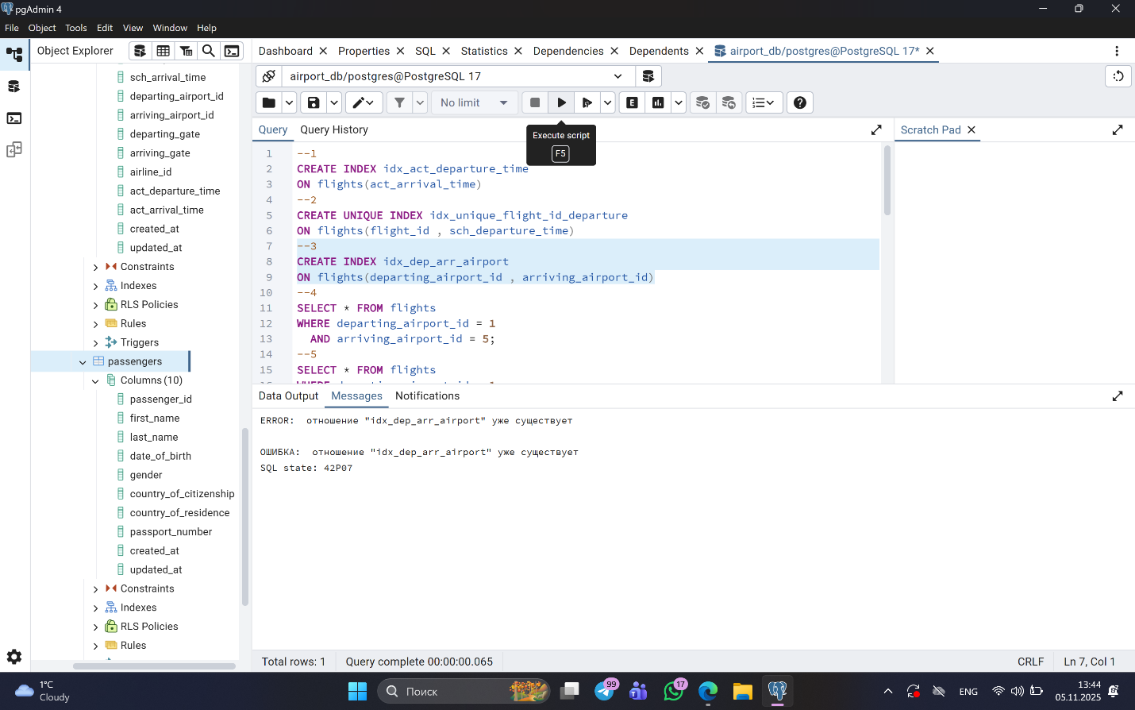
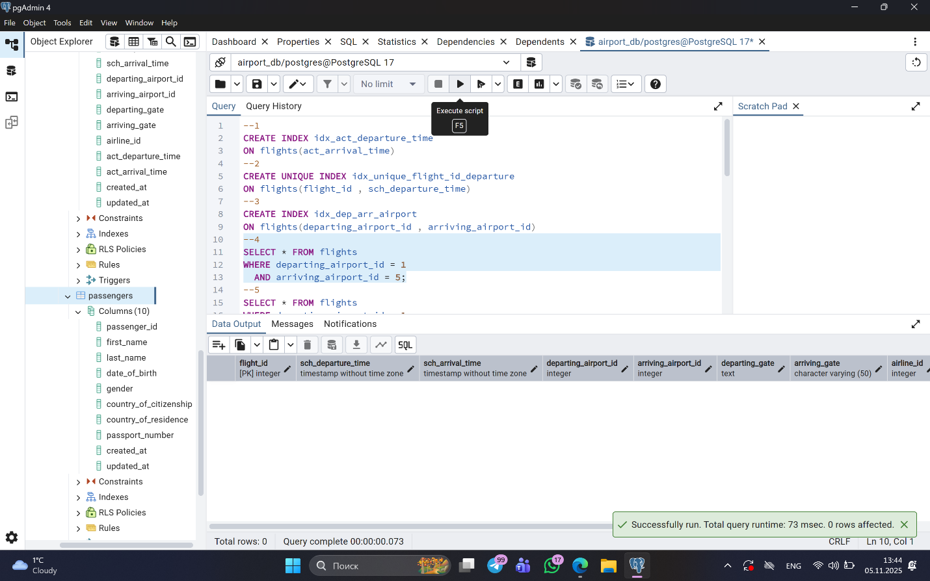4 .When we run the query without an index, PostgreSQL performs a sequential scan, which checks every row in the flights table to find matches.
After creating the composite index on departing_airport_id and arriving_airport_id, PostgreSQL uses an index scan instead.
This makes the query much faster, especially when the table has thousands of rows, because it can directly jump to matching records instead of scanning everything.
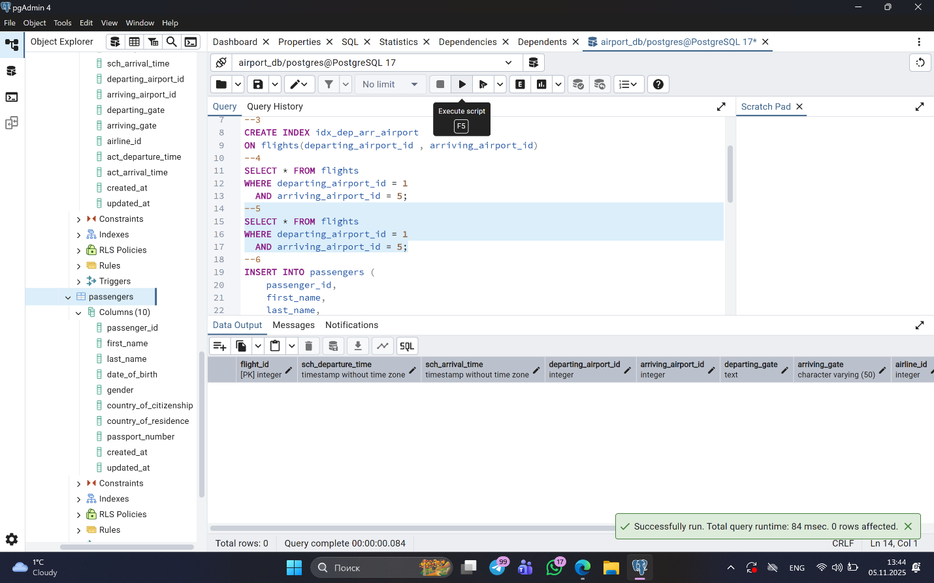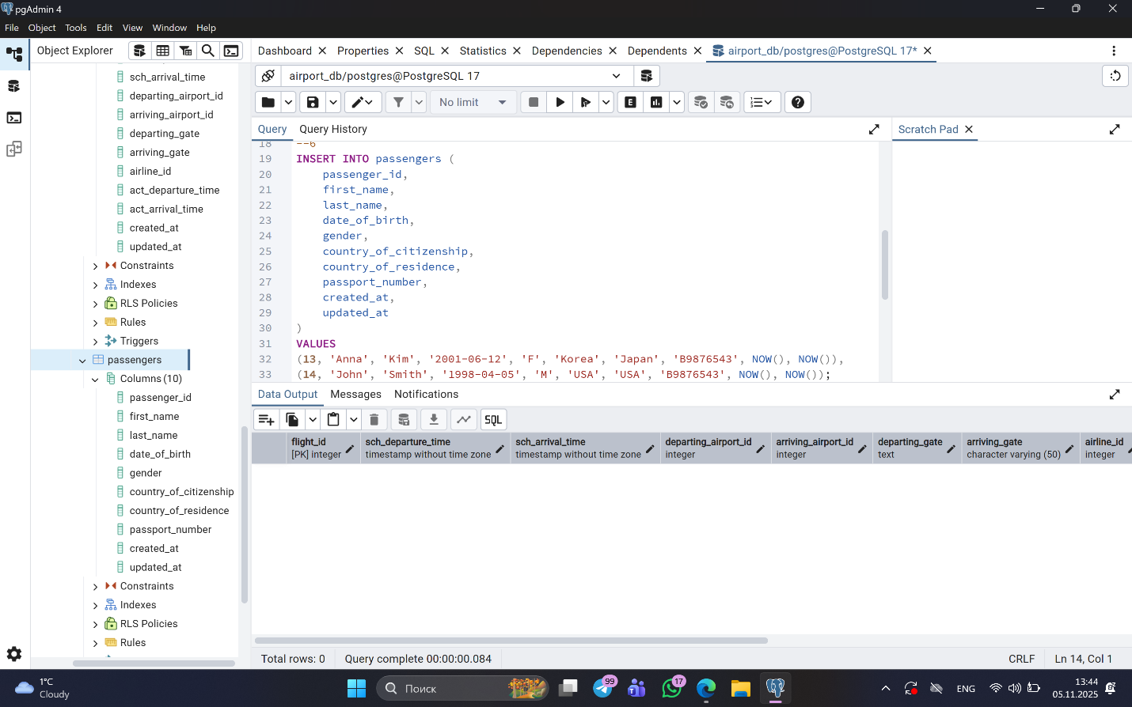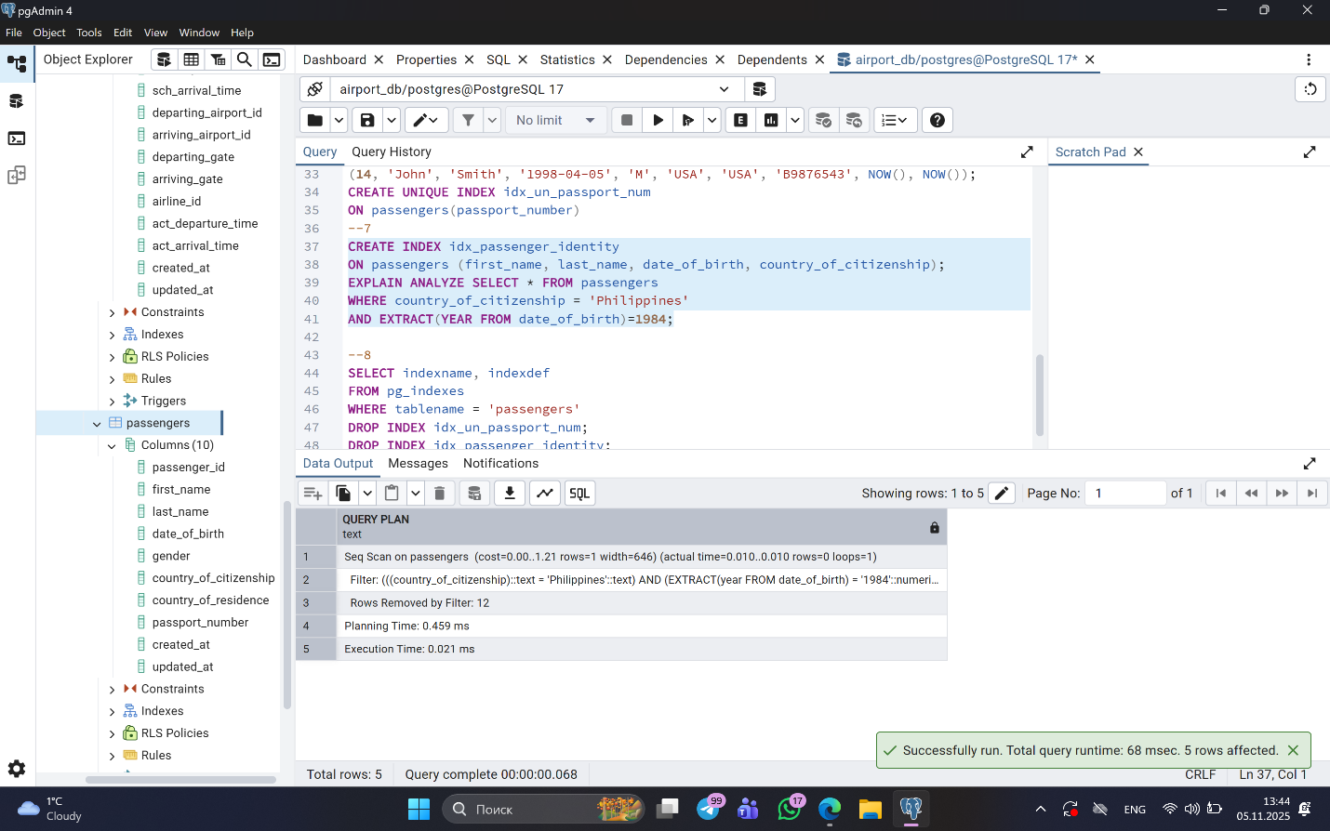We created a multi-column index that covers first_name, last_name, date_of_birth, and country_of_citizenship.
When we filter passengers by country and date of birth, PostgreSQL may or may not use this index depending on the order of columns and query selectivity.
If most passengers are from the same country or many share the same year of birth, the database might decide that using the index is not efficient, and will instead perform a sequential scan.
So, even if the index exists, the optimizer will only use it if it really makes the query faster.